Chapter Six
concerning the Glory of the Quraan
(Rasuluallah Sallallahu Alayhi Wassallam)
In this chapters Allamah Busairi (R.A.)describes the miracle of the Holy Qur'an. Every miracle of all the other prophets was only temporary and was only witnessed by those who were present at that time. The Holy Qur'an is that ever lasting miracle which is witnessed by all people for all time to come. Allamah Busairi encourages people to recite the Holy Qur'an and act upon its commands.


- Allow me to describe the miracles of him (Rasuluallah Sallallahu Alayhi Wassallam) exposed (performed).

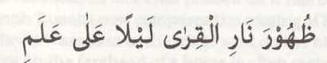

- Like the lighting of fires on the hillside at night for guests.



- The beauty of a pearl is further enhanced in a necklace.


- But its value does not diminish )in the least when not strung on a necklace).

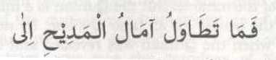
- So why should the ambitions of those who praise not increase towards


- That which (him (Rasuluallah Sallallahu Alayhi Wassallam) ha of noble character and good habits.

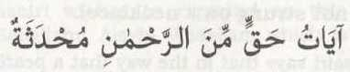
- Verses of truth from the Most Merciful (Allah Ta’aala) newly heard.

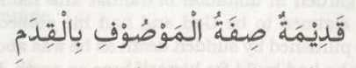
- (As well as being) eternal which is quality (of Allah) Who is described with eternity.

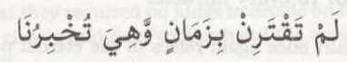
- It is not connected with any period of time, while it informs us.

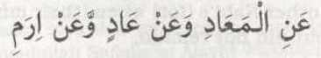
- About the hereafter as well as of Ad and Iram.

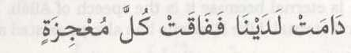
- Which remains with us forever, therefore it is superior to every miracle.


- Of the other Nabi’s (for) when (their miracles) came but did not remain.


- Absolutely clear (as evidence) so it did not leave (room for any ) doubts.


- By the enemies nor so they require any judge.

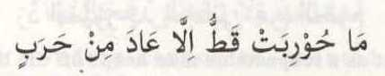
- No one opposed it ever except for the vehement enemy.


- (Due to) the enmity of the enemy towards it,(but that he) refrained from it seeking a truce.

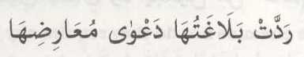
- Its eloquence refuted the accusations of its objectors.

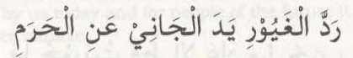
- Just as a respectable man keeps off the hand of a transgressor from his harem.

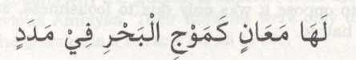
- Its meaning is like the waves of the ocean in helping (one another)


- And the (Qur’an) transcends the jewels of the sea in beauty and value.

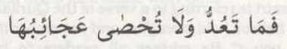
- Its wonders cannot be counted nor comprehended.


- Nor would you (be) satiated by its constant repetition (recitation).

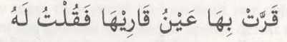
- It cools the eye of its reciter, so I said to him

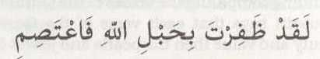
- You have succeeded with the hope of Allah, therefore hold steadfast onto it.


- If you recite it due to fear of the heat of blazing fire.

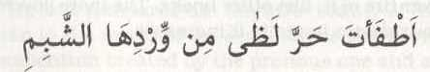
- Then you have doused the blazing fire with its cool water.

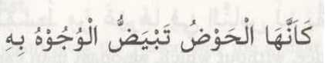
- It is the Houze-e-Kauthar with which faces are illuminated.

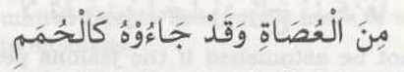
- Of the sinners even though they came to it (with faces) black as coal.


- It is like the straight bridge like the scales in equilibrium.


- Justice, without which, amongst man cannot be established.

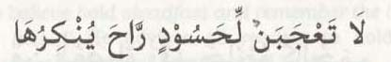
- Do not be astonished if the jealous person rejects it.


- (Feigning ) ignorance while they are shrewd.

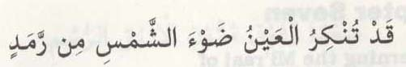
- Verily the eye rejects the ray of the sun due to dust.


- The mouth rejects the (sweet) taste of water due to sickness.

